
Staff Name:___________________
Pay Period: ____________________

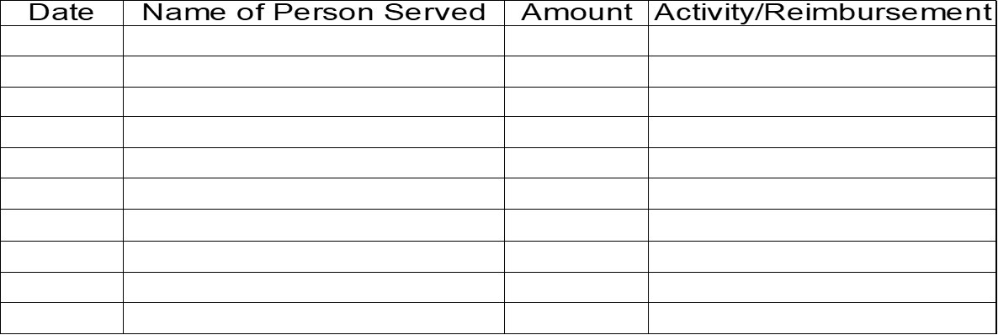
***Please remember you must have receipt or it will be denied, only one dine out allowed per person you work with per Month. All activities over $10 need to be approved by Program Manager prior to activity.

***Please only submit mileage that is not on Pavillio on this sheet.

